Indexing Exercises – Assignment Submission
Your Name: Aditya Raj 6362534
Date: 29/06/2025
Topic: SQL Indexing – Non-Clustered, Clustered (Simulated), and Composite Indexes
Database: MySQL 8.0 (DB Fiddle)

Database Schema and Sample Data
-- Customers
CREATE TABLE Customers (
CustomerID INT PRIMARY KEY,
Name VARCHAR(100),
Region VARCHAR(50)
);
-- Products
CREATE TABLE Products (
ProductID INT PRIMARY KEY,
ProductName VARCHAR(100),
Category VARCHAR(50),
Price DECIMAL(10, 2)
);
-- Orders
CREATE TABLE Orders (
OrderID INT PRIMARY KEY,
CustomerID INT,
OrderDate DATE,
FOREIGN KEY (CustomerID) REFERENCES Customers(CustomerID)
);
-- OrderDetails
CREATE TABLE OrderDetails (
OrderDetailID INT PRIMARY KEY,
OrderID INT,
ProductID INT,
Quantity INT,
FOREIGN KEY (OrderID) REFERENCES Orders(OrderID),
FOREIGN KEY (ProductID) REFERENCES Products(ProductID)
);
-- Insert Customers
INSERT INTO Customers (CustomerID, Name, Region) VALUES
(1, 'Alice', 'North'),
(2, 'Bob', 'South'),
(3, 'Charlie', 'East'),
(4, 'David', 'West');
-- Insert Products
INSERT INTO Products (ProductID, ProductName, Category, Price) VALUES
(1, 'Laptop', 'Electronics', 1200.00),
(2, 'Smartphone', 'Electronics', 800.00),
(3, 'Tablet', 'Electronics', 600.00),
(4, 'Headphones', 'Accessories', 150.00);
-- Insert Orders
INSERT INTO Orders (OrderID, CustomerID, OrderDate) VALUES
(1, 1, '2023-01-15'),
(2, 2, '2023-02-20'),
(3, 3, '2023-03-25'),
(4, 4, '2023-04-30');
-- Insert Order Details
INSERT INTO OrderDetails (OrderDetailID, OrderID, ProductID, Quantity) VALUES
(1, 1, 1, 1),
(2, 2, 2, 2),
(3, 3, 3, 1),
(4, 4, 4, 3);

Exercise 1: Non-Clustered Index
Goal: Improve performance of product name search.
Step 1: Query before index
SELECT * FROM Products WHERE ProductName = 'Laptop';
Output:
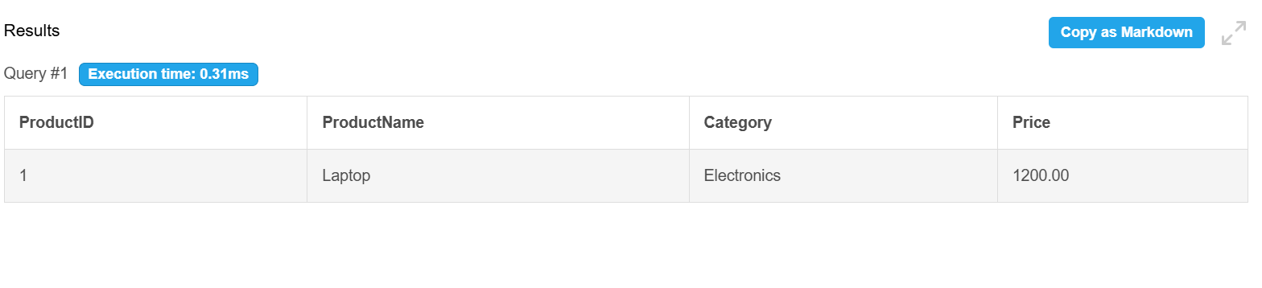
Step 2: Create non-clustered index
CREATE INDEX idx_ProductName ON Products(ProductName);
Step 3: Query after index
SELECT * FROM Products WHERE ProductName = 'Laptop';
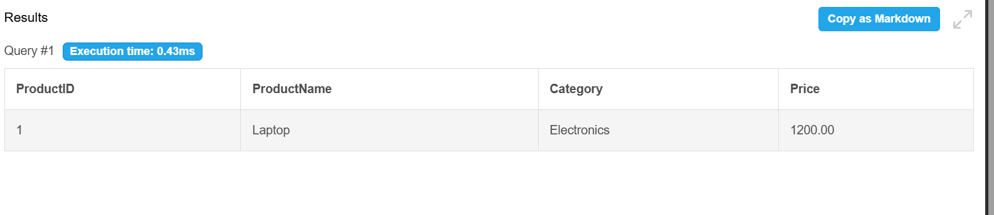

Exercise 2: Clustered Index (Simulated)
Goal: Optimize queries by OrderDate.
Note: MySQL uses the primary key as the clustered index automatically.
Step 1: Query before index
SELECT * FROM Orders WHERE OrderDate = '2023-01-15';
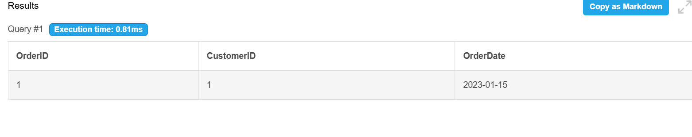
Step 2: Simulate clustered index
CREATE INDEX idx_OrderDate ON Orders(OrderDate);
Step 3: Query after index
SELECT * FROM Orders WHERE OrderDate = '2023-01-15';
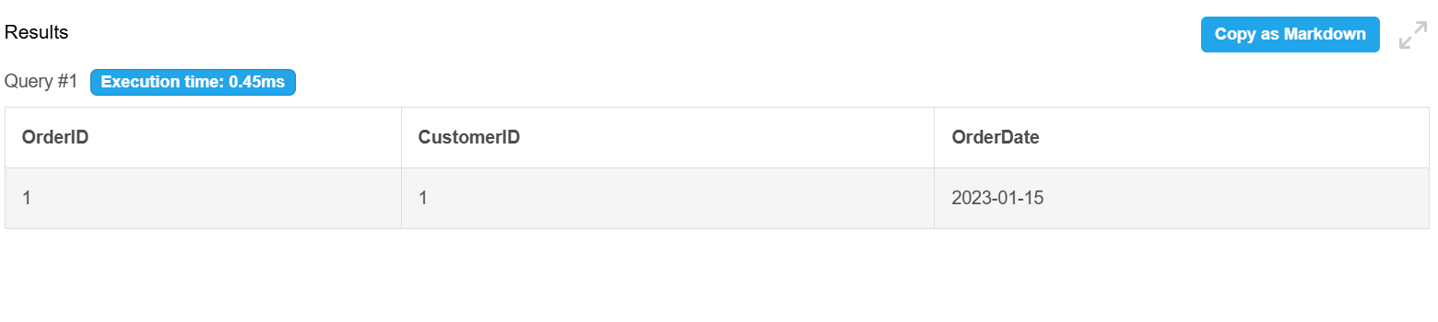

Exercise 3: Composite Index
Goal: Optimize filtering using two columns (CustomerID and OrderDate).
Step 1: Query before index
SELECT * FROM Orders WHERE CustomerID = 1 AND OrderDate = '2023-01-15';
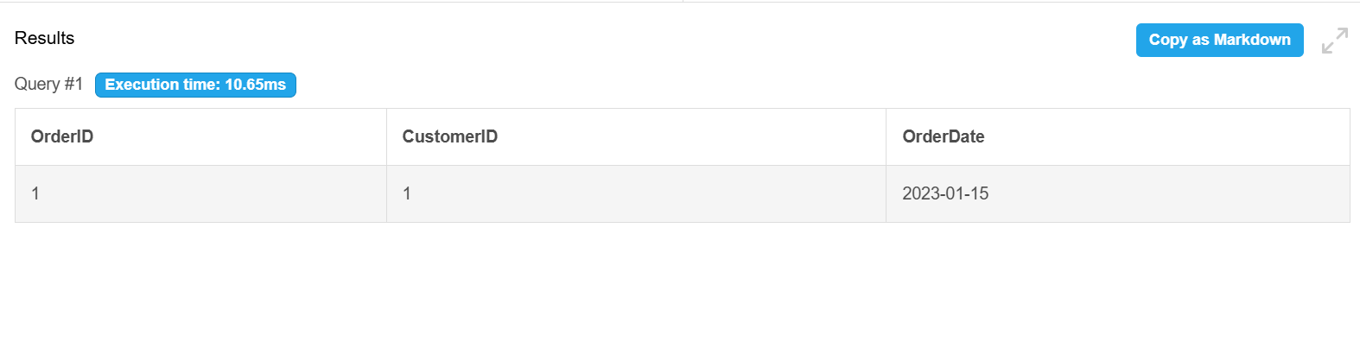
Step 2: Create composite index
CREATE INDEX idx_CustomerOrder ON Orders(CustomerID, OrderDate);
Step 3: Query after index
SELECT * FROM Orders WHERE CustomerID = 1 AND OrderDate = '2023-01-15';
